Just To Say Thank You
Dear parents, carers and friends,
I wanted to express my sincere thanks to the many community members who have sent me good wishes on my unexpected leave and trip to the UK for extenuating family reasons. I look forward very much to working with many of you on my return after Christmas and thank Ms Lupton for her great work as Relieving Principal while I have been away, as well as the dedication of all staff and community members to our students.
As we reach the end of my first year as Principal of Campsie Public School, I think we can be deservedly proud of the collaborative work of all which has resulted in so many wonderful achievements by our students.
I would like to especially thank out scripture teachers and all other parent and community volunteers who give up valuable personal time to give back to our school community. We are truly blessed and we would not be able to carry out our wide range of high quality educational programs without you. The special morning tea is a genuine token of our sincere appreciation to you all. Thank you!
At this time, I would also like to farewell our year six students. I will always fondly remember how welcoming they were to me in my first year at the school and know they are truly ready for their next phase of their educational journeys in a wide variety of high schools. Please come back and see us and tell us how you are going on a regular basis.

Warm Regards,
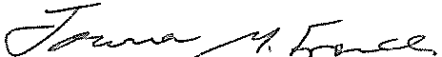
Joanna French
Principal

